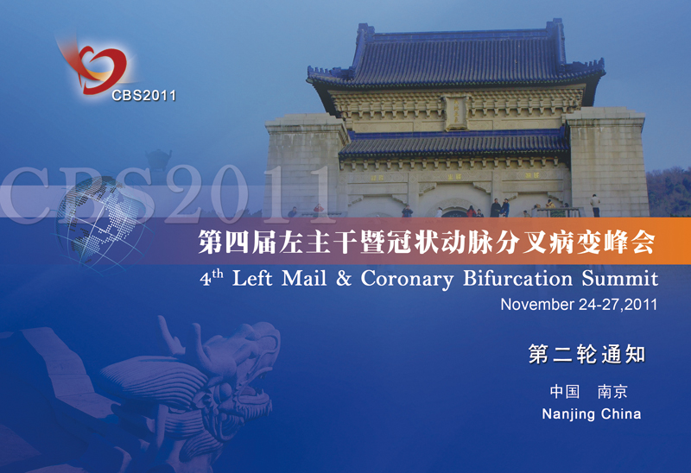

REGISTRANT INFORMATION (PLEASE PRINT)
□Prof ◻□Dr ◻□Mr ◻□Ms
Surname Given Name
Institution: Department:
Mailing Address:
Country: Postal Code:
E-mail : Contact Tel No: Fax No:
(International attendees, please include country and city code for phone and fax)
I am submitting an abstract for the conference: [] Yes [ ] No

MEETING REGISTRATION
FULL DELEGATE - 24thth ~27th November 2011 (Thursday - Sunday) |  | Received & paid by 31st Aug | Received & paid after 31st Aug
 | Delegate | □ USD$150 | □ USD$200
A: REGISTRATION FEE: (USD $)
NOTE: Registration fee includes morning and afternoon teas and lunches for all delegates

ACCOMMODATION
Arrangements have been made for special rates (FIVE STARS HOTEL US$ 200 per night ) for delegates attending conferences and participants are requested to make their reservations with the organizing committee.
B: Please book___ nights from Nov___ to Nov___. Hotel Fee:_______ (US $)

Privacy: Do you agree to have your contact details included on the delegate list? _ Yes _ No

PAYMENT DETAILS (Payment of registration & workshop fees MUST accompany this form)
TOTAL PAYMENT DUE (A+ B) = (USD$)
PAYMENT OPTIONS
Cash payment on site
Please note that only US dollars or RMB is acceptable.
Cancellations & Refunds
- Notification of cancellation and request for refund must be submitted in writing to the Conference Secretariat.
- The following cancellation and refund policies will apply:
- Before 1 Oct 2011: Full refund of prepaid fees except for an administration charge of USD$50.00.
- 1Oct – 1 Nov 2011: 50% refund of registration fee.
- After 1 Nov 2011: No Refund.
- All refunds will be processed after the event.

Agreement to terms and conditions: I wish to register for CBS 2011 Conference and acknowledge the registration terms including the cancellation policy.

Signature of Registrant: _________________Date: ________

MAIL TO: Dr. Jing Xu C/0 CBS organizing committee
Nanjing First Hospital, Cardiology dept
#68 Chang Le Road, Nanjing, 210006
P. R. China
FAX TO: 86-(25) 52208048
TEL: 86-(25) 52271000
Cell: 86-13951748232
E-mail: cbsabc@163.com
Website: http://www.cbs.com

